
Bahria University, Lahore Campus
Department of Computer Sciences
(Fall 2025)

Course: | Computer Communication Network Lab | ViVa Date: 17-12-2025
Course Code: | CEL-223 | Max Marks: 20
Faculty’s Name: | Nadia Shakir

LAB Project

Name: M.Ephraim

Roll No: 03-134242-058

Project Details:

Project Overview
The objective of this project was to design and implement a scalable enterprise network connecting a Head Office (HQ) with three remote branch offices. The network simulates a real-world Wide Area Network (WAN) using OSPF routing, VLAN segmentation for internal traffic management, and a Cisco ASA Firewall for perimeter security.

Topology Diagram:

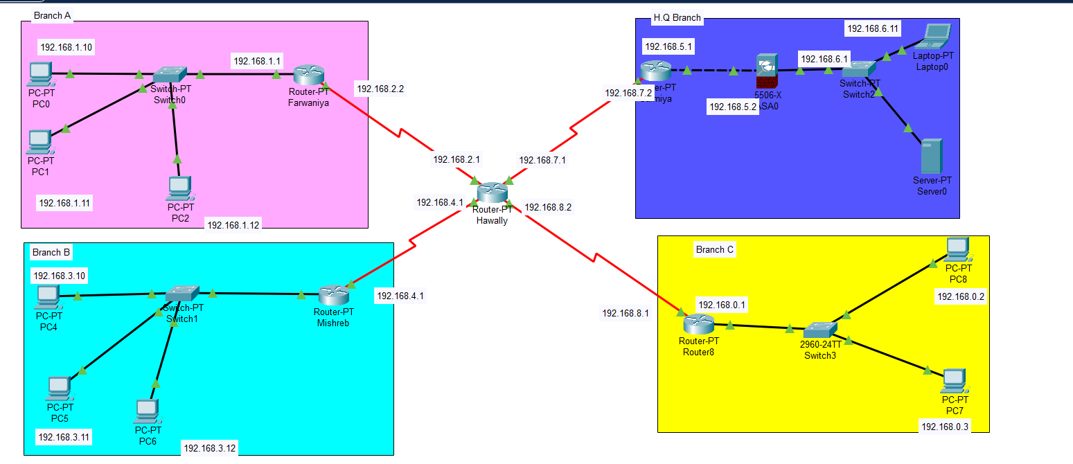

Head Office:

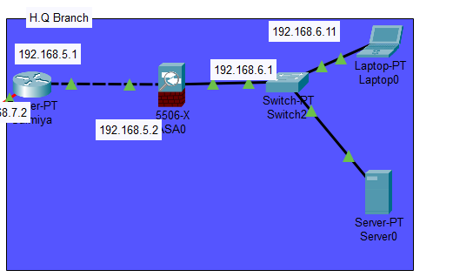

Routing Table:

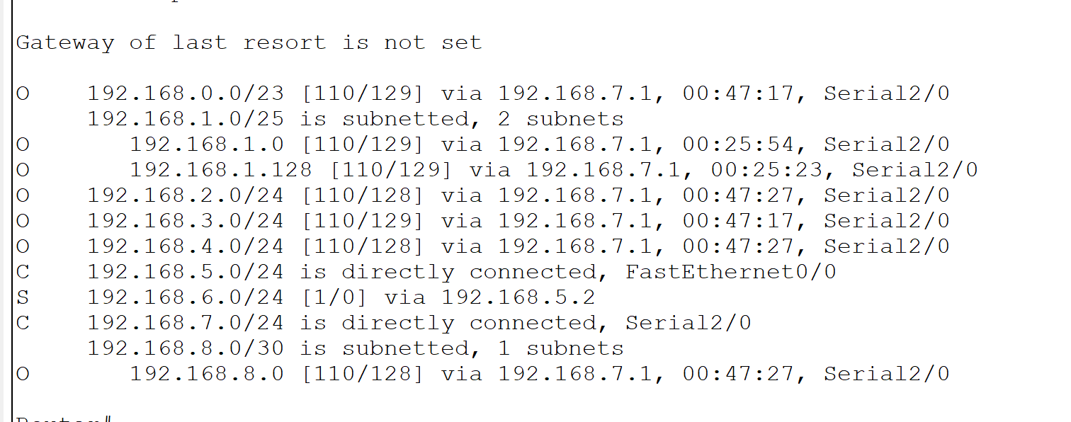

Branch A:

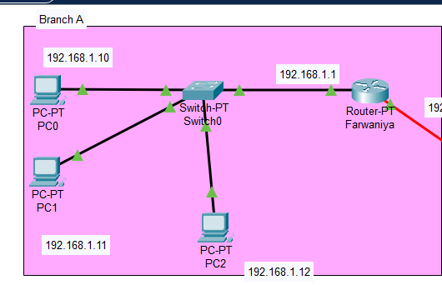

Routing table:

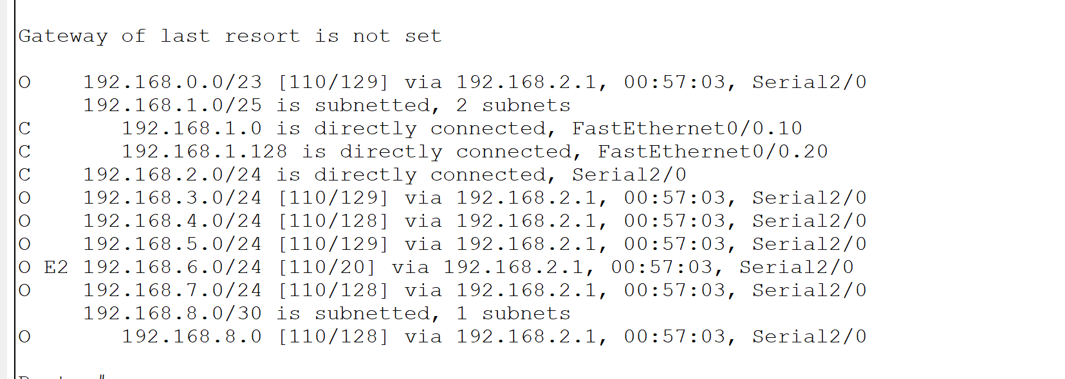

Branch B:

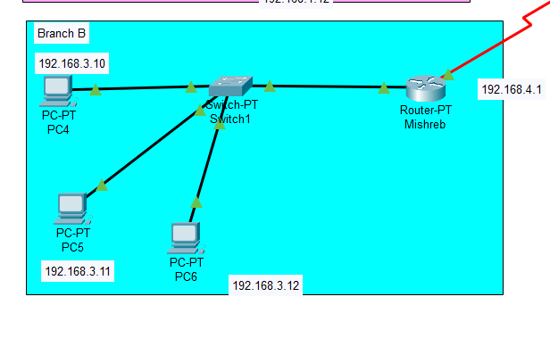

Routing table:

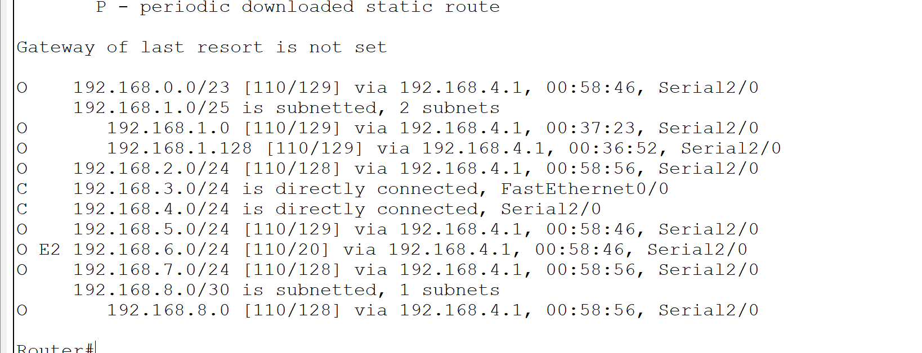

Branch C:

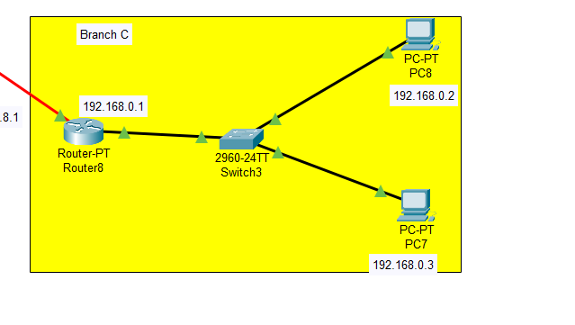

Routing table:

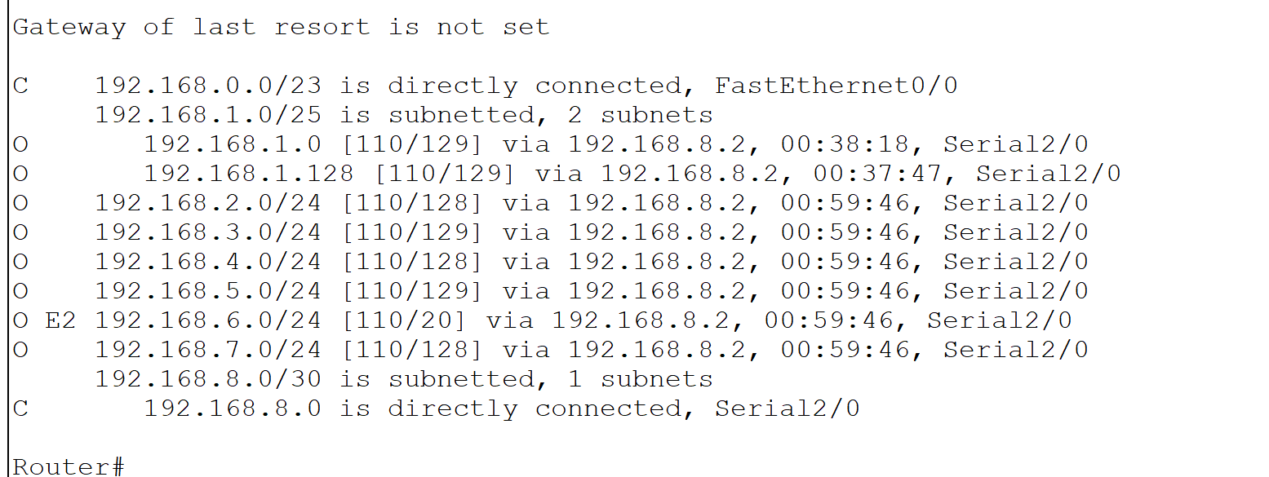

DNS SERVER:

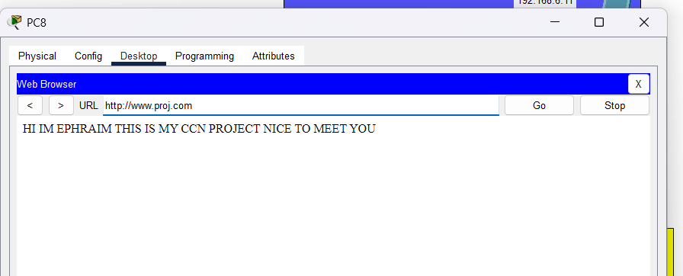

Firewall implementation:

Whereas firewall implementation is concerned ive considered pc2 from BRANCH A as a hacker and blocked it to reach the H.Q BRANCH using ASA SERVER(FIREWALL):-

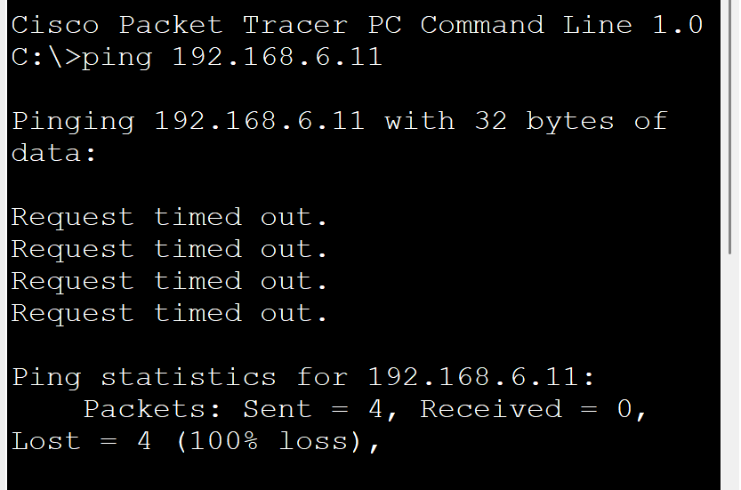

2. Hardware & Device Inventory
The network is divided into four geographical locations connected via a central ISP backbone.
The devices used are Router-PT,1x ASA 5506-X Firewall,Switch-PT,PC-PT.

Conclusion:
The project successfully meets all requirements: full multi-branch connectivity, implemented VLAN segmentation, functional DNS/Web services, and active security filtering via ACLs and Firewalls. For verification purposes a log file is attached.

